**How to install Robot Framework**

Guide to follow: “Python Installation Instructions”: <https://github.com/robotframework/robotframework/blob/master/INSTALL.rst>

Guide to follow: “Robot Framework

<http://robotframework.org/>

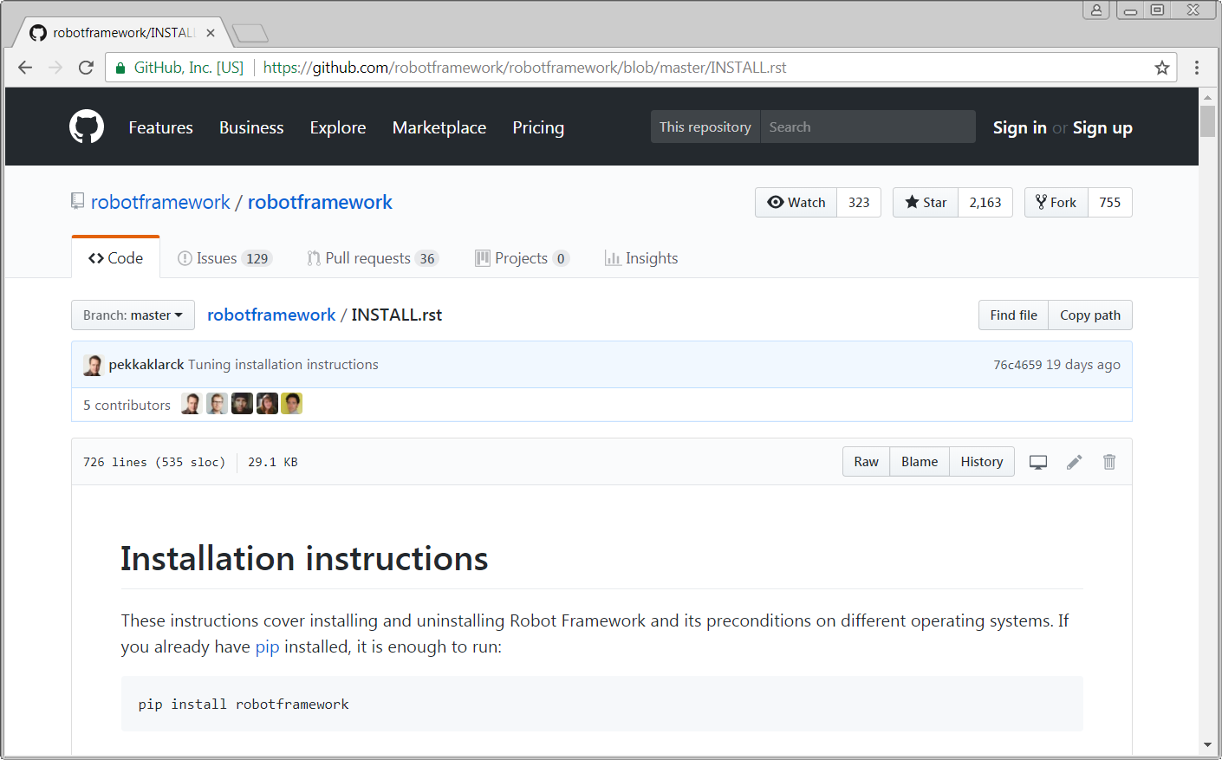

1. Install Python Go to <https://www.python.org/> . Select the Downloads tab

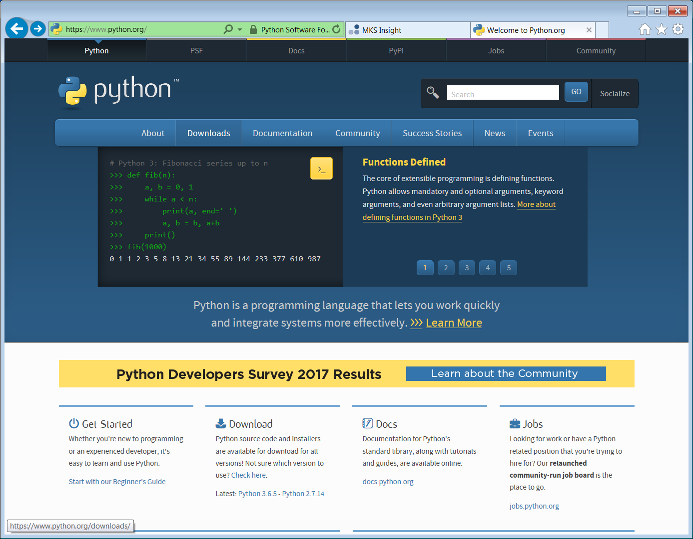

1. Select Release Version : Python 2.7.12 and Download

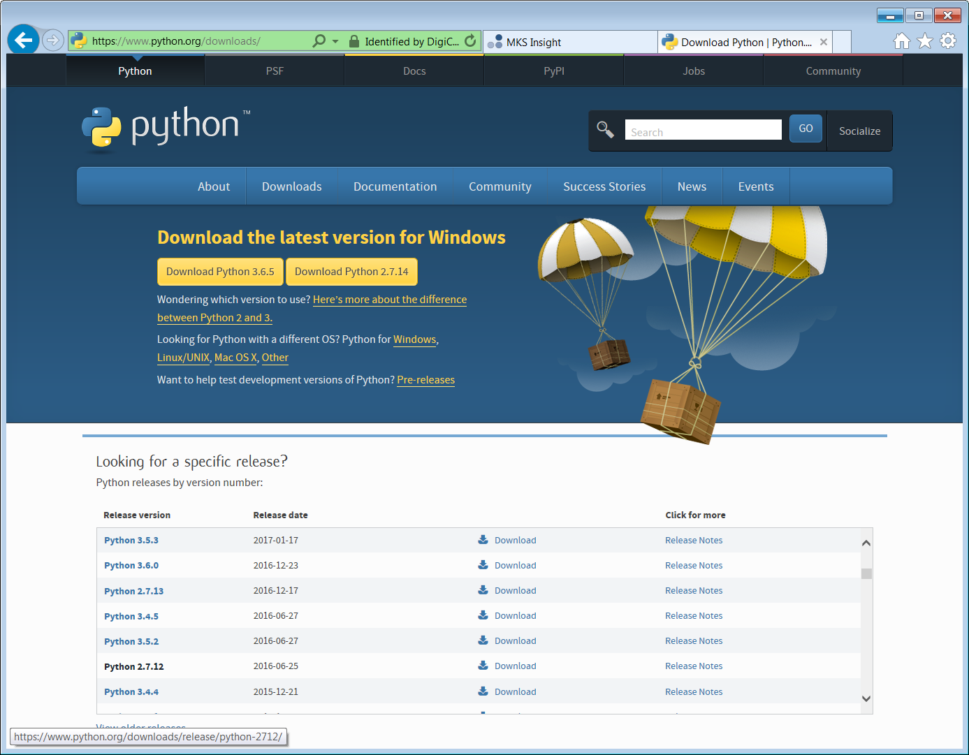

1. Select Python version 2.7.12 “[Windows x86 MSI installer](https://www.python.org/ftp/python/2.7.12/python-2.7.12.msi)”

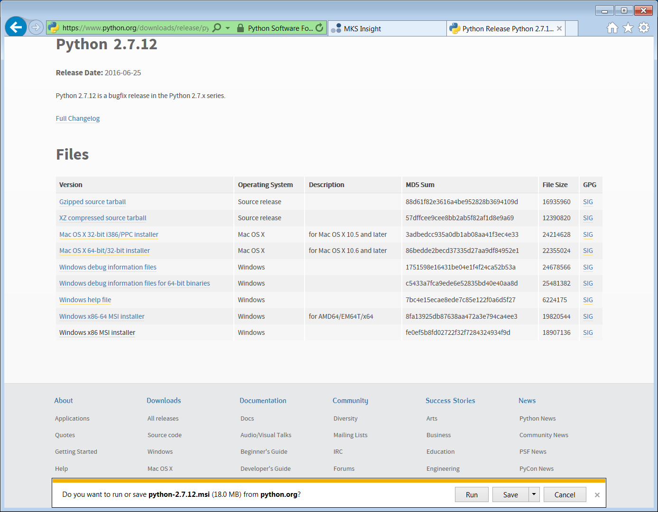

1. Click and run to start the insulation, click on next a few times, the click “Finish”.

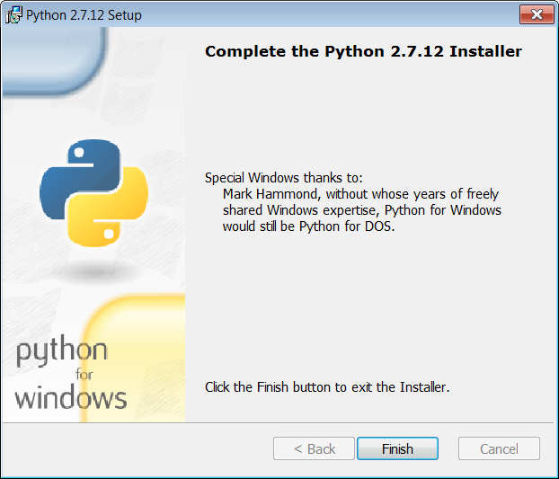

Set up enviroment varables: see link <https://github.com/robotframework/robotframework/blob/master/INSTALL.rst>

Under Configuring Path



### [Configuring PATH](https://github.com/robotframework/robotframework/blob/master/INSTALL.rst" \l "id20)

Latest Python Windows installers allow setting PATH as part of the installation. This is disabled by default, but Add python.exe to Path can be enabled on the Customize Python screen. It will add both the Python installation directory and the Scriptsdirectory to the PATH.

#### What directories to add to PATH

What directories you need to add to the PATH depends on the interpreter and the operating system. The first location is the installation directory of the interpreter (e.g. C:\Python27) and the other is the location where scripts are installed with that interpreter. Both Python and IronPython install scripts to Scripts directory under the installation directory on Windows (e.g. C:\Python27\Scripts) and Jython uses bin directory regardless the operating system (e.g. C:\jython2.7.0\bin).

Notice that the Scripts and bin directories may not be created as part of the interpreter installation, but only later when Robot Framework or some other third party module is installed.

#### Setting PATH on Windows

On Windows you can configure PATH by following the steps below. Notice that the exact setting names may be different on different Windows versions, but the basic approach should still be the same.

1. Open Control Panel > System > Advanced > Environment Variables.
2. To edit an **existing** PATH value, select Edit and add ;<InstallationDir>;<ScriptsDir> at the end of the Variable value (;C:\Python27;C:\Python27\Scripts). Note that the semicolons (;) are important as they separate the different entries. To add a new PATH value, select New and set both the name and the value, this time without the leading semicolon.
3. **Note: if more there is more than one installation of Python. You must install this Variable value so that it is the first one in the path before the others.**

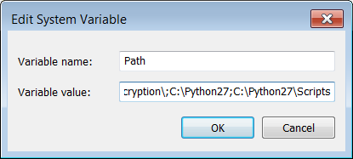

1. Exit the dialog with Ok to save the changes.
2. Start a new command prompt for the changes to take effect. Go to the C: drive shown in the figure below.

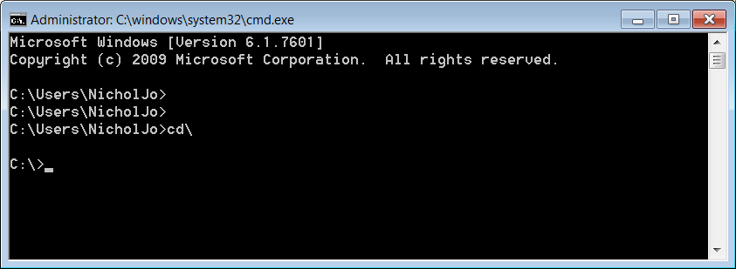

1. At the command prompt, C:\>, type in “pip install robotframework” and press return/enter. You’ll recived a message telling you that Robot Framework was installed successfully.

Additional Robot framework Libraries installed

[**Rammbock**](https://github.com/robotframework/Rammbock#readme)

Generic network protocol test library that offers easy way to specify network packets and inspect the results of sent and received packets

[**SeleniumLibrary**](http://github.com/robotframework/SeleniumLibrary/)

Web testing library that uses popular Selenium tool internally.

There are many others available on **www.robotframework.org**

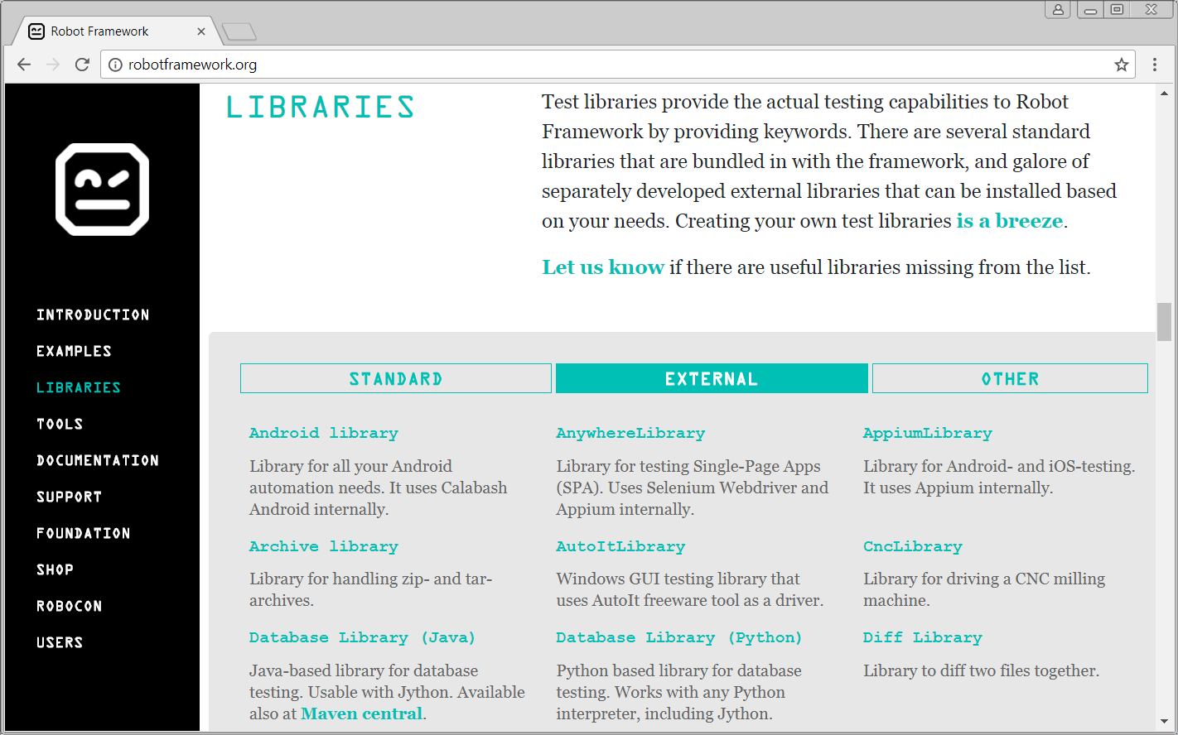

1. On the terminal type in “pip install robotframework-seleniumlibrary” and press return/enter. You’ll recived a message telling you that robotframework-seleniumlibrary was installed successfully.
2. On the terminal type in “pip install robotframework-rammbock” and press return/enter. You’ll recived a message telling you that robotframework-rammbock was installed successfully.
3. On the terminal type in “pip install matplotlib” and press return/enter. You’ll recived a message telling you that matplotlib was installed successfully.

Set results below:

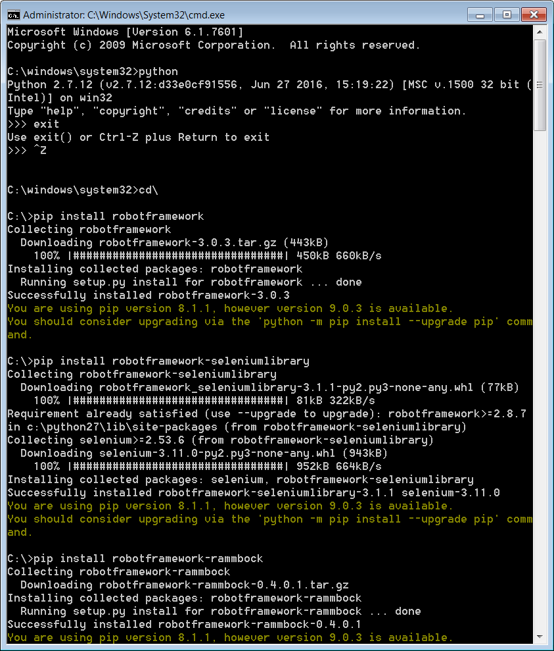

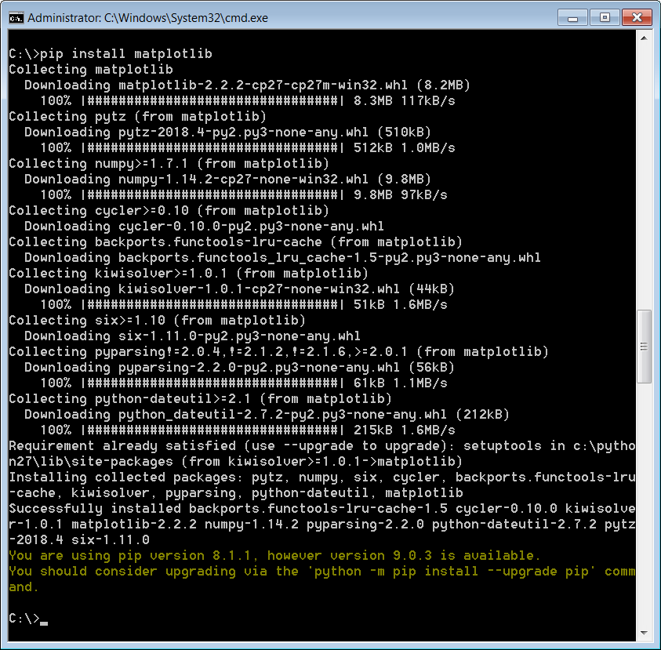

1. Check the version of Robot Framework by using “robot –version” command in cmd.

